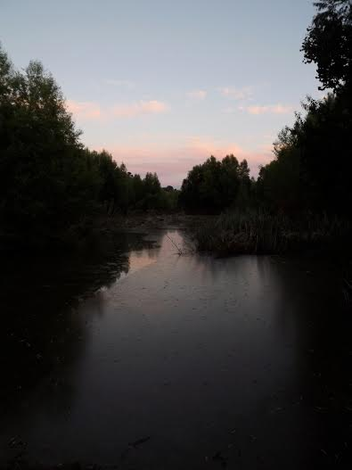
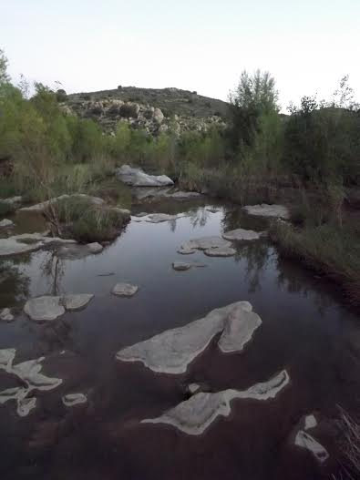
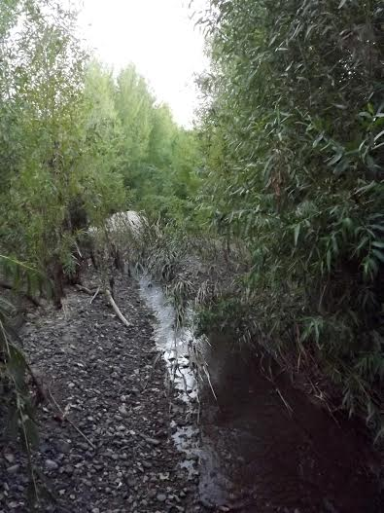
AGUA FRIA DAY 2017

COME JOIN US!
WHEN: Saturday, February 18, 2017, from 9 AM - 1 PM
WHERE: Black Canyon Heritage Park (33955 S. Old Black Canyon Highway, Black Canyon City, Arizona)
WHAT: Hands-on family friendly activities, outreach booths, talks by scientists and historians
Join the Friends of the Agua Fria National Monument for coffee and donuts in the morning! Bring a picnic lunch and enjoy the beautiful surroundings of the Black Canyon Heritage Park.
FREE ADMISSION (sorry no dogs)
If you are interested, please RSVP at our website.
Contact: fafnmadmin@aguafriafriends.org
(PHOTO CREDIT: JACK JOHNSON)
